60004210210

Amartya Mishra

COMPS – C31

ML Experiment 7

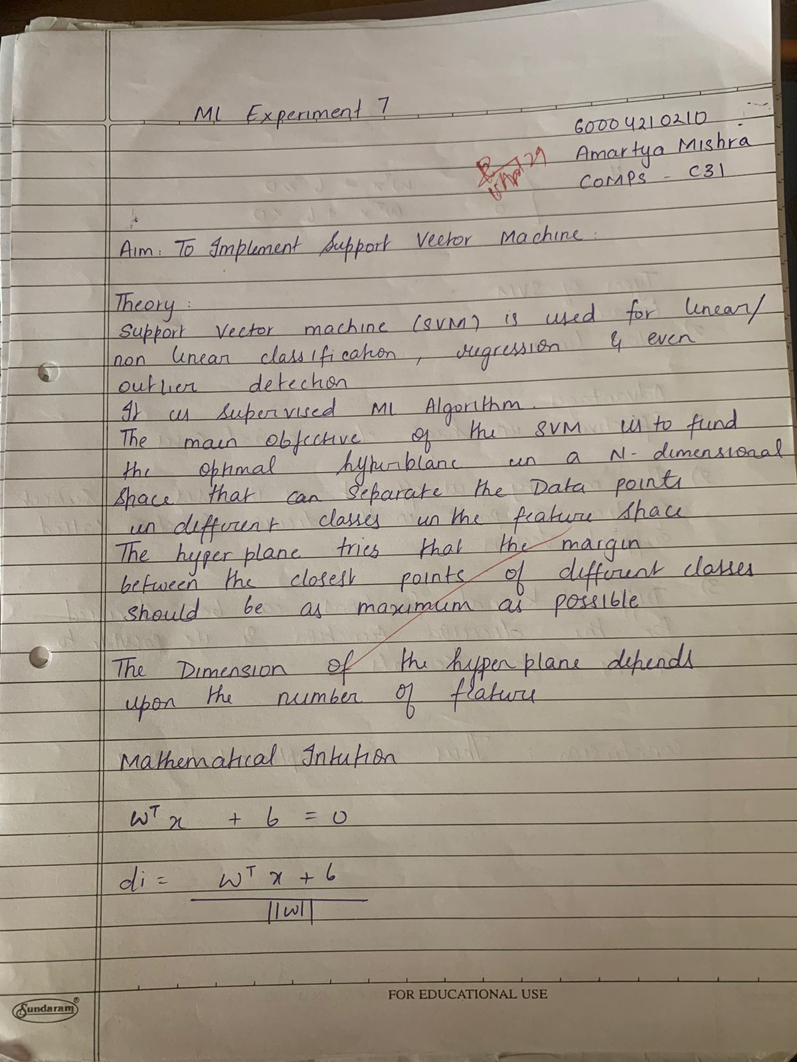

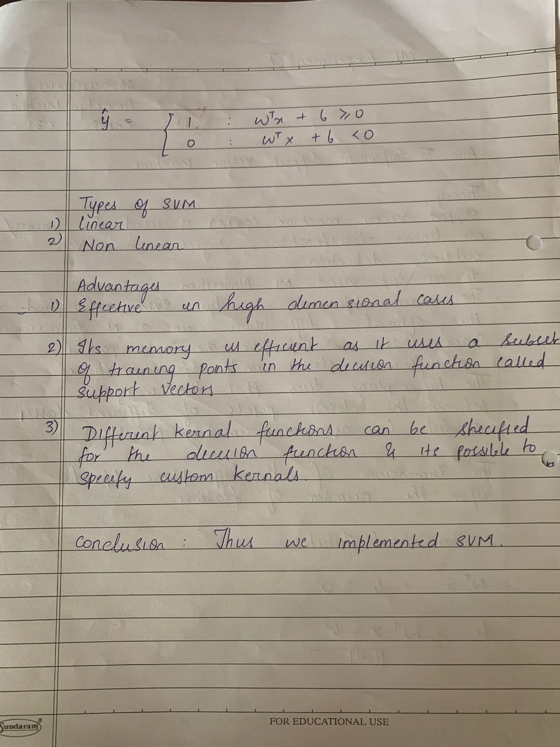

**Implementation:**

from sklearn.datasets import load_breast_cancer

from sklearn.model_selection import train_test_split

from sklearn.naive_bayes import GaussianNB

from sklearn.metrics import accuracy_score

data = load_breast_cancer()

X = data.data

y = data.target

X

X_train, X_test, y_train, y_test = train_test_split(X, y, test_size=0.3, random_state=42)

classifier = GaussianNB()

classifier.fit(X_train, y_train)

y_pred = classifier.predict(X_test)

accuracy = accuracy_score(y_test, y_pred)

print(accuracy)

from sklearn.metrics import confusion_matrix

confusion_matrix(y_test, y_pred)